PRACTICAL 2
Code: https://github.com/bhavyakumar18/DSA/tree/main/Practical%202
Problem 1:
I checked the license plates one by one until I found the target plate. I solved it using both a loop and a recursive function. If the target plate appears more than once, my solution finds the first occurrence because it stops searching as soon as it finds the target.
Output:
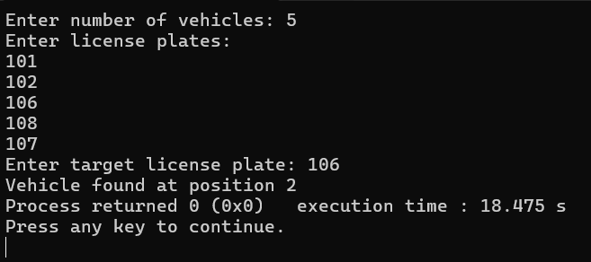
Problem 2:
I used Binary Search with both a loop and a recursive function. In each step, I checked the middle element and decided whether to search on the left or right side. This method only works if the list is sorted. If the list is not sorted, Binary Search may search in the wrong direction and give an incorrect result or fail to find the target.
Output:
